LAB #06

Implementation /Analysis of Frequency Modulated and Demodulated Signal using MATLAB



Fall 2023

**CSE-402L Digital Signal Processing Lab**

Submitted by: MUHAMMAD SADEEQ

Registration No.: 21PWCSE2028

Section: C

“On my honor, as a student of the University of Engineering and Technology, I have neither given nor received unauthorized assistance on this academic work”

Submitted to:

Dr. Yasir Saleem Afridi

(8 Dec 2023)

Department of Computer systems engineering

University of Engineering and Technology, Peshawar

**Tasks**

**Code:**

fs = 1000; % Sampling Frequency

fc = 200; % Carrier Frequency

t = (0:1/fs:0.2)';

fDev = 50;

FDev = 100;

x = sin(2*pi*30*t) + sin(2*pi*60*t);

cs = sin(2*pi*fc*t);

hold on

plot(t,cs,"--"); %Carrier Signal

plot(t,x); %modulating Signal

xlabel('Time (s)')

ylabel('Amplitude')

legend('Carrier Signal','Modulating Signal')

y = fmmod(x,fc,fs,fDev);

figure;

plot(t,x,'r',t,y,'k--')

xlabel('Time (s)')

ylabel('Amplitude')

legend('Original Signal','Modulated Signal')

y = fmmod(x,fc,fs,FDev);

figure;

plot(t,x,'r',t,y,'k--')

xlabel('Time (s)')

ylabel('Amplitude')

legend('Original Signal','Modulated Signal')

z = fmdemod(y,fc,fs,fDev);

figure;

plot(t,x,'c',t,z,'b--');

xlabel('Time (s)');

ylabel('Amplitude');

legend('Original Signal','Demodulated Signal');

**Output:**

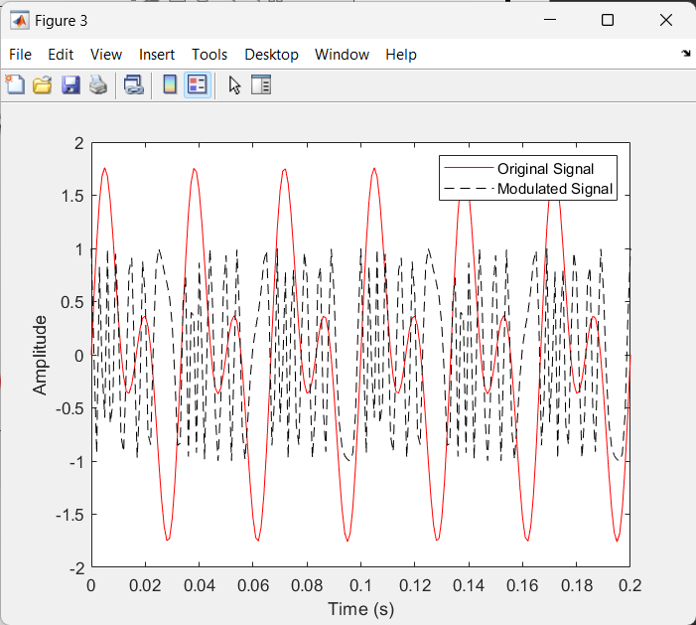

1. **Observe Figure 1 and comment on the frequencies of both signals and why.**

**Comment:** Original Signal is the combination of two frequencies which is 30 and 60 Hzwhile carrier signal is has frequency 200 Hz only